**DATE :11.05.2018** 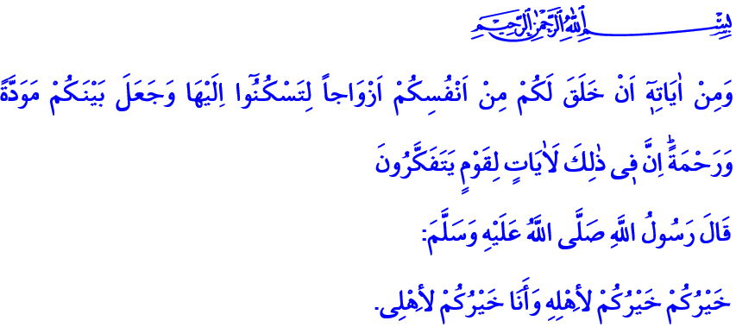

**FAMILY – HOME OF JUSTICE AND BENEVOLENCE**

**Honorable Believers!**

**In the verse I have recited, Our Lord says,** “And of His signs is that He created for you from yourselves mates that you may find tranquility in them; and He placed between you affection and mercy. Indeed in that are signs for a people who give thought.”**[1]**

## And in the hadith I have recited, Our Prophet (s.a.w.) says, “The best of you is the one who is best to his/her family, and I am the best of you to my family.”[2]

**Brothers and Sisters!**

One of the most beautiful bounties of Our Lord is family. Family embraces us the moment we open our eyes to the world. It protects and cherishes us. Family is a precious home that Our Lord nourishes with His mercy, and beautifies by bestowing children and pure sustenance. Family denotes finding peace and deeply feeling the sense of security. Family is where the value of affection, joy and zest increases by sharing. Family is a hearth and home of education where fidelity is blended with altruism, faith with benevolence, knowledge with wisdom, and love with respect. Family is our most precious treasure, and indispensable wealth.

**Honorable Believers!**

Our Lord has created man and woman justly. In our religion, the purpose of creation is the same for man and woman. Both are valuable, and both have basic rights and inviolabilities. They are not different than each other in servitude and responsibility, in reward and punishment, in living their lives in chastity and honor. The goal, which Islam has put forward as the most favorable approach on family is the ethics of fairness and benevolence. Each member of a family must base pleasing the other as the foundation of their behaviors, for families ruled by justice and benevolence are the homes of peace.

**Honorable Believers!**

Our supreme religion Islam has shown us the ways for the bliss and happiness of the family. The best role model for us in terms of family life is the Prophet (s.a.w.). He ordains benevolence, goodness and fairness in family life, as it involves competing in goodness with benevolence. Benevolence is a noble value which sustains love in the family, inholding altruism and generosity. Benevolence is a favor made without expecting a reward in return and not pushing the receiver to be under obligation. Fairness in family is to observe mutual love and respect, to protect honor of individuals, to appreciate efforts of others, and to embrace a way of equity and moderation in rights and responsibilities.

**Dear Believers!**

Mutual understanding must rule over families. Spouses must trust and show loyalty to each other. Delight, sadness, fatigue and troubles must be shared. Helping each other and solidarity is of the essence for family members. Each individual in the family must act responsibly. Decisions must be made in consultation with each other. Individuals in the family must think of the others more than themselves. Then the divine mercy will manifest itself, and fondness, love and attachment will become perpetual.

Parents must treat both each other and their children with justness and fairness without discrimination of gender. Because each parent is responsible for the directive in this hadith, **“Be afraid of Allah, and be just to your children.”[3]** Therefore, parents must act in line with their responsibilities, and never neglect their children. This prophetic commination from our beloved Prophet must be heeded, **“It is sufficient sin for a man that he neglects him whom he maintains.” [4]**

Then, let us protect our families commended by Our Lord, and treat them with kid gloves. Let us remember that when the day comes, we will be accountable to Allah, owner of these trusts. Let us strive to strengthen the ethics of fairness and benevolence in every area of our family life. Let us come together with our parents, our spouses and our children, and appreciate the value of our family. Let us not forget that it is our primary duty to protect our families from all kinds of moral and material perils and threats.

**Dear Believers!**

I would like to remind you that this week is also the Disability Awareness Week. We all know that we have disabled brothers and sisters in many families. Handicaps can be overcome in happy and peaceful families. Handicaps, whether occurred congenitally or subsequently, are never obstacles to work, to produce and to succeed. The real handicap is to shun one’s mind, hands and tongue to affection and mercy.

**Dear Believers!**

Inshallah, next Wednesday we will enter Ramadan – the holy month of mercy. Tuesday night, we will perform the first Tarawih prayer and wake up for Suhur. I pray to Allah that this holy month bring peace and tranquility to our families, our nation, our state, and all Islamic world.

1. Rum, 30/21.
2. Ibn Majah, Nikah (Marriage), 50.
3. Bukhari, Hiba (Gifts), 13.
4. Abu Dawud, Zakat, 45.

   ***General Directorate of Religious Services*** 